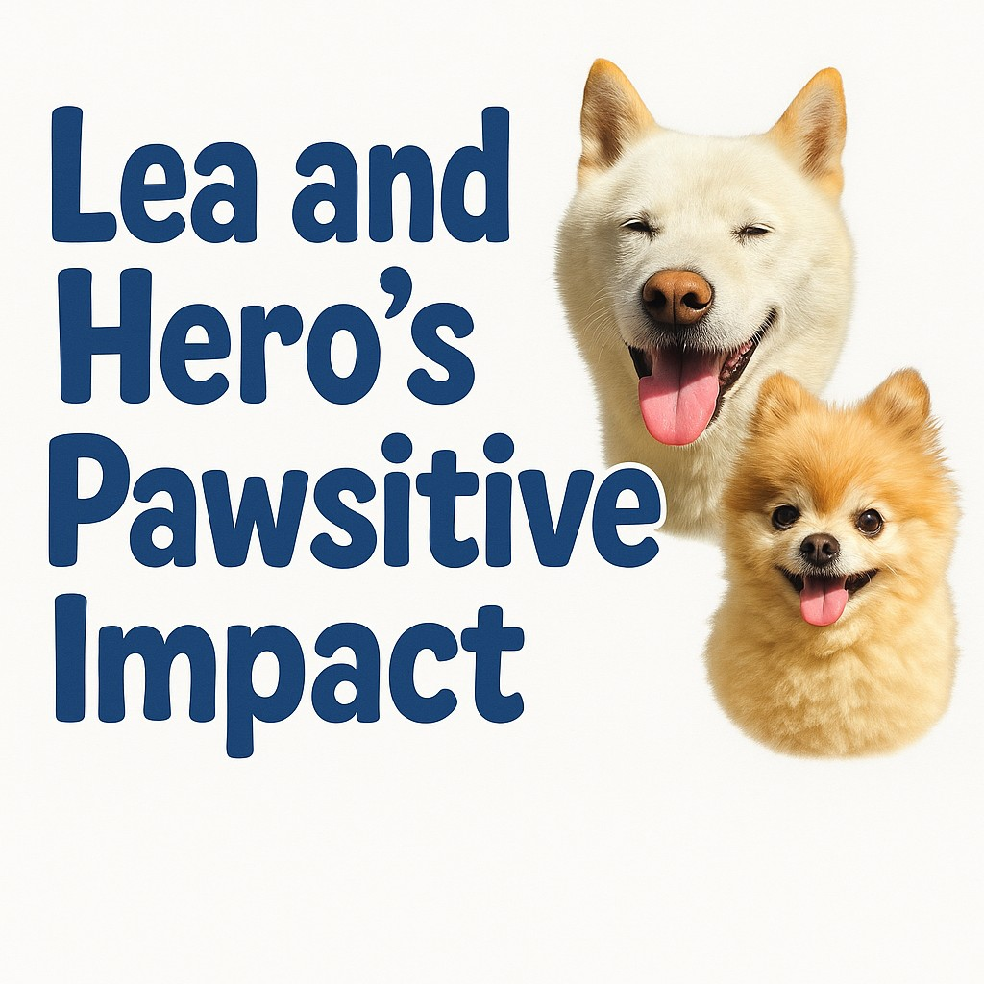
👶🐶 Baby on the Way? No Worries, Pup’s Got This!
With a little prep and patience, your dog can adjust beautifully to pregnancy, babies, and the joyful chaos of young kids.

🤰 1. Pregnant? Start Early!
Help your dog get used to new sights, smells, and routines.

👃 Introduce baby lotions, powders, and gear early.

📦 Set up the nursery gradually—let your dog explore with supervision.

🧘 Keep calm during big changes—your dog picks up on your energy.

🚶‍♀️ Adjust walk routines before the baby arrives (especially if they’ll change later).

👶 2. Bringing Baby Home
It’s a big day—make it smooth and positive!

🕯️ Before baby arrives, bring home a blanket or onesie with their scent.

🐾 Let your dog sniff from a distance—curiosity is normal.

🛋️ Keep greetings low-key—no jumping or crowding.

🎉 Praise your dog for calm behavior (treats work wonders!).

🛏️ 3. Safety First: Managing Space
Create baby-safe and dog-comfortable zones.

🚪 Use baby gates or playpens to give everyone safe boundaries.

🦴 Give your dog a quiet space with their bed and toys.

❌ Never leave baby and dog unattended—even if they’re both angels!

🔕 Reduce loud surprises with soft alerts (like tapping instead of yelling).

🍼 4. Feeding Time = Calm Time
Dogs love food smells—but let’s keep them away from bottles and snacks.

👀 Supervise feeding—never let your dog sneak a lick.

🪑 Teach “Go to Place” during feedings (use a mat or bed).

🥕 Distract with a long-lasting treat like a stuffed Kong nearby.

🧸 5. Toddler Time: New Challenges
Kids get grabby, noisy, and wobbly—dogs need help adjusting.

🙅 Teach toddlers not to pull ears, tails, or fur.

🐕 Teach your dog a “safe retreat” command like “Go to bed.”

🎯 Use treats to reward calm behavior when kids are loud or playful.

📚 Read kid-friendly dog books together to teach gentle behavior.

🧠 6. Keep Everyone Enriched
Pregnancy and babies change your schedule—don’t forget dog time!

⏰ Set a routine that includes short walks and games.

🧠 Use puzzle toys and snuffle mats to keep your dog busy indoors.

💗 Ask a friend, dog walker, or support network to help when needed.

⚠️ 7. Red Flags to Watch
Some dogs feel stressed or unsure—know the signs.

🐾 Signs to watch:

Avoiding baby or mom

Growling, guarding toys

Clinginess or sudden accidents

👩‍⚕️ If concerned, speak with a trainer or vet ASAP.

📝 Quick Glance Cheat Sheet!
🐾 Problem
🎉 Solution

Dog overwhelmed by baby gear
Slow introduction, treats for calm behavior

Feeding distractions
Mat training + enrichment toys

Toddler grabs or yells
Teach gentle touch, supervise, reward calm dog

Dog feels left out
Routine, walks, mental games

Baby + dog alone
Never! Use baby gates and active supervision

🐾 Need Help Balancing It All?
We’re here for you and your growing family:
👶 Free baby-safe dog training tips
🐕 Free customized support for your family
💬 Free judgment-free advice

